**Experimento #1**

train_datagen = ImageDataGenerator(

preprocessing_function=preprocess_input,

rotation_range=10,

width_shift_range=0.2,

height_shift_range=0.2,

horizontal_flip=True,

vertical_flip=True,

shear_range=0.2,

zoom_range=0.2,

validation_split=0.2

)

Test set classification report after warmup:

precision recall f1-score support

Clase 0 0.80 0.96 0.87 67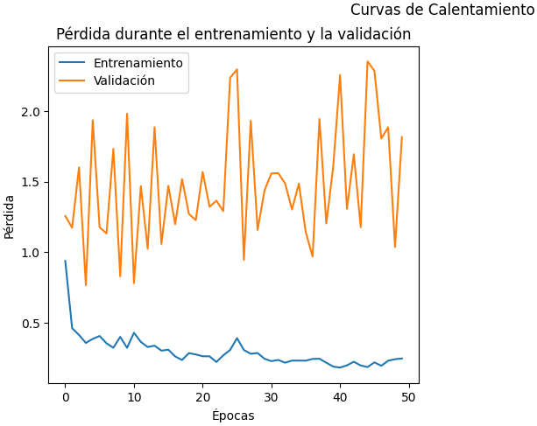

Clase 1 0.25 0.06 0.10 17

accuracy 0.77 84

macro avg 0.53 0.51 0.48 84

weighted avg 0.69 0.77 0.71 84

Test set AUC Score after warmup: 0.607550482879719

11/11 [==============================] - 5s 455ms/step

Train set classification report after warmup:

precision recall f1-score support

Clase 0 0.85 0.98 0.91 265

Clase 1 0.82 0.33 0.47 70

accuracy 0.84 335

macro avg 0.83 0.65 0.69 335

weighted avg 0.84 0.84 0.82 335

Train set AUC Score after warmup: 0.7935849056603773

Test set classification report after fine-tuning:

precision recall f1-score support

Clase 0 0.86 0.18 0.30 67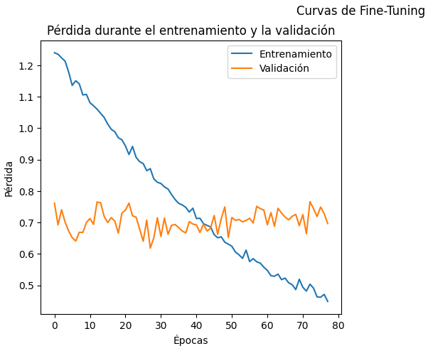

Clase 1 0.21 0.88 0.34 17

accuracy 0.32 84

macro avg 0.54 0.53 0.32 84

weighted avg 0.73 0.32 0.31 84

Test set AUC Score after fine-tuning: 0.530289727831431

11/11 [==============================] - 2s 136ms/step

Train set classification report after fine-tuning:

precision recall f1-score support

Clase 0 0.90 0.17 0.29 265

Clase 1 0.23 0.93 0.37 70

accuracy 0.33 335

macro avg 0.56 0.55 0.33 335

weighted avg 0.76 0.33 0.30 335

Train set AUC Score after fine-tuning: 0.6809164420485176

**Experimento #2**

train_datagen = ImageDataGenerator(

preprocessing_function=preprocess_input,

rotation_range=10,

brightness_range=[0.8, 1.2],

validation_split=0.2

)

Test set classification report after warmup:

precision recall f1-score support

Clase 0 0.80 0.94 0.86 67

Clase 1 0.20 0.06 0.09 17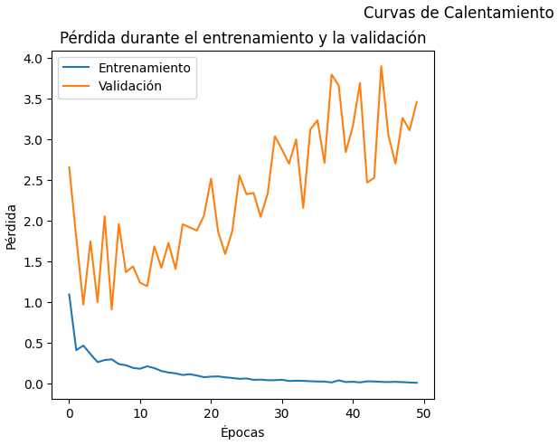

accuracy 0.76 84

macro avg 0.50 0.50 0.48 84

weighted avg 0.68 0.76 0.71 84

Test set AUC Score after warmup: 0.6277436347673397

11/11 [==============================] - 5s 481ms/step

Train set classification report after warmup:

precision recall f1-score support

Clase 0 0.88 0.99 0.93 265

Clase 1 0.95 0.50 0.65 70

accuracy 0.89 335

macro avg 0.91 0.75 0.79 335

weighted avg 0.90 0.89 0.88 335

Train set AUC Score after warmup: 0.8110512129380054

Test set classification report after fine-tuning:

precision recall f1-score support

Clase 0 0.85 0.61 0.71 67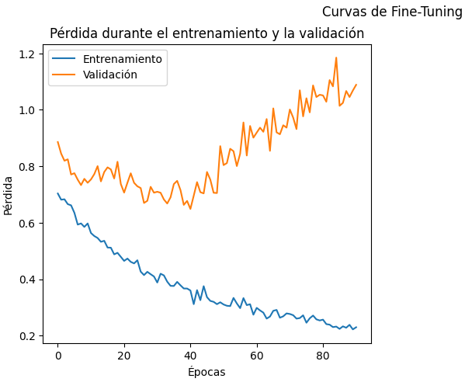

Clase 1 0.28 0.59 0.38 17

accuracy 0.61 84

macro avg 0.57 0.60 0.55 84

weighted avg 0.74 0.61 0.65 84

Test set AUC Score after fine-tuning: 0.5838454784899034

11/11 [==============================] - 2s 145ms/step

Train set classification report after fine-tuning:

precision recall f1-score support

Clase 0 0.90 0.69 0.78 265

Clase 1 0.38 0.71 0.50 70

accuracy 0.70 335

macro avg 0.64 0.70 0.64 335

weighted avg 0.79 0.70 0.72 335

Train set AUC Score after fine-tuning: 0.766522911051213

**Experimento #3**

train_datagen = ImageDataGenerator(

preprocessing_function=preprocess_input,

width_shift_range=0.1,

height_shift_range=0.1,

validation_split=0.2

)

Test set classification report after warmup:

precision recall f1-score support

Clase 0 0.78 0.87 0.82 67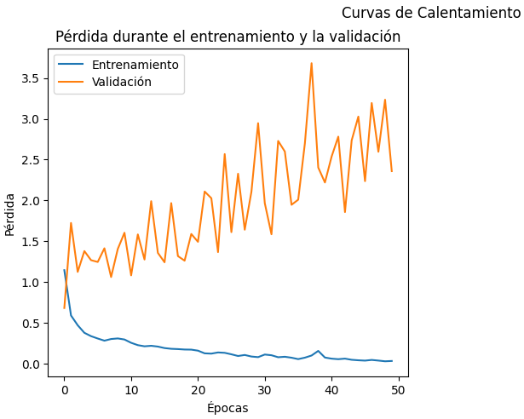

Clase 1 0.10 0.06 0.07 17

accuracy 0.70 84

macro avg 0.44 0.46 0.45 84

weighted avg 0.65 0.70 0.67 84

Test set AUC Score after warmup: 0.5847234416154522

11/11 [==============================] - 5s 443ms/step

Train set classification report after warmup:

precision recall f1-score support

Clase 0 0.88 0.99 0.93 265

Clase 1 0.92 0.47 0.62 70

accuracy 0.88 335

macro avg 0.90 0.73 0.78 335

weighted avg 0.88 0.88 0.87 335

Train set AUC Score after warmup: 0.8134231805929919

Test set classification report after fine-tuning:

precision recall f1-score support

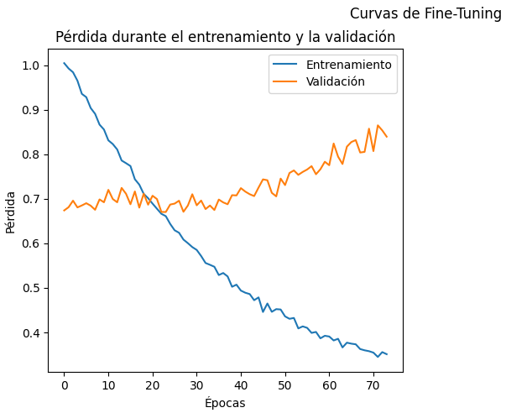

Clase 0 0.62 0.07 0.13 67

Clase 1 0.18 0.82 0.30 17

accuracy 0.23 84

macro avg 0.40 0.45 0.22 84

weighted avg 0.54 0.23 0.17 84

Test set AUC Score after fine-tuning: 0.49604916593503073

11/11 [==============================] - 2s 179ms/step

Train set classification report after fine-tuning:

precision recall f1-score support

Clase 0 0.96 0.09 0.16 265

Clase 1 0.22 0.99 0.36 70

accuracy 0.27 335

macro avg 0.59 0.54 0.26 335

weighted avg 0.80 0.27 0.20 335

Train set AUC Score after fine-tuning: 0.5878706199460917

**Experimento #4**

train_datagen = ImageDataGenerator(

preprocessing_function=preprocess_input,

rotation_range=10,

brightness_range=[0.8, 1.2],

validation_split=0.2

)

Test set classification report after warmup:

precision recall f1-score support

Clase 0 0.80 0.99 0.89 67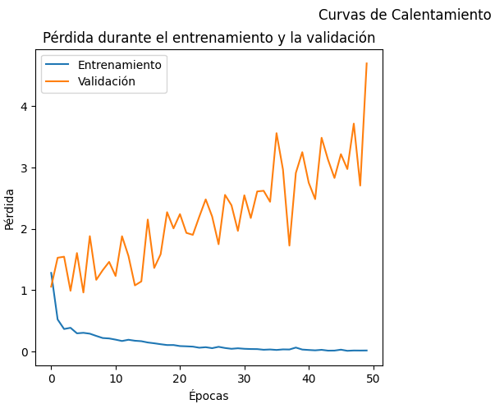

Clase 1 0.50 0.06 0.11 17

accuracy 0.80 84

macro avg 0.65 0.52 0.50 84

weighted avg 0.74 0.80 0.73 84

Test set AUC Score after warmup: 0.6224758560140474

11/11 [==============================] - 5s 483ms/step

Train set classification report after warmup:

precision recall f1-score support

Clase 0 0.87 0.99 0.92 265

Clase 1 0.94 0.41 0.57 70

accuracy 0.87 335

macro avg 0.90 0.70 0.75 335

weighted avg 0.88 0.87 0.85 335

Train set AUC Score after warmup: 0.8011859838274933

Test set classification report after fine-tuning:

precision recall f1-score support

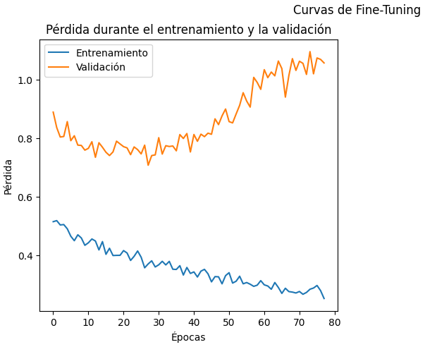

Clase 0 0.82 0.73 0.77 67

Clase 1 0.25 0.35 0.29 17

accuracy 0.65 84

macro avg 0.53 0.54 0.53 84

weighted avg 0.70 0.65 0.67 84

Test set AUC Score after fine-tuning: 0.5733099209833188

11/11 [==============================] - 2s 147ms/step

Train set classification report after fine-tuning:

precision recall f1-score support

Clase 0 0.86 0.80 0.83 265

Clase 1 0.40 0.50 0.45 70

accuracy 0.74 335

macro avg 0.63 0.65 0.64 335

weighted avg 0.76 0.74 0.75 335

Train set AUC Score after fine-tuning: 0.7368194070080862

**Experimento #5**

train_datagen = ImageDataGenerator(

preprocessing_function=preprocess_input,

horizontal_flip=True,

channel_shift_range=10.0,

validation_split=0.2

)

Test set classification report after warmup:

precision recall f1-score support

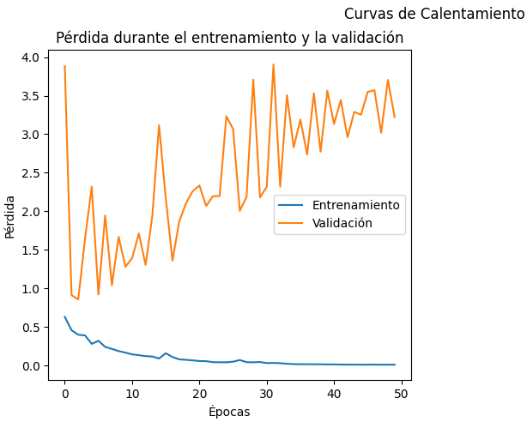

Clase 0 0.80 0.91 0.85 67

Clase 1 0.25 0.12 0.16 17

accuracy 0.75 84

macro avg 0.53 0.51 0.51 84

weighted avg 0.69 0.75 0.71 84

Test set AUC Score after warmup: 0.6198419666374012

11/11 [==============================] - 5s 450ms/step

Train set classification report after warmup:

precision recall f1-score support

Clase 0 0.89 0.99 0.94 265

Clase 1 0.95 0.53 0.68 70

accuracy 0.90 335

macro avg 0.92 0.76 0.81 335

weighted avg 0.90 0.90 0.88 335

Train set AUC Score after warmup: 0.8168194070080862

Test set classification report after fine-tuning:

precision recall f1-score support

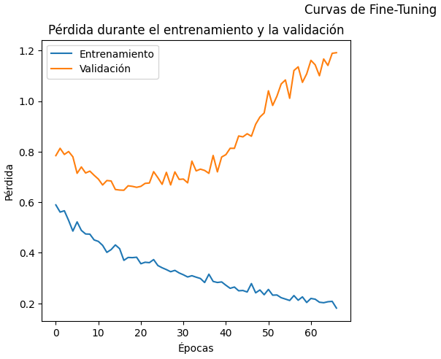

Clase 0 0.89 0.24 0.38 67

Clase 1 0.23 0.88 0.36 17

accuracy 0.37 84

macro avg 0.56 0.56 0.37 84

weighted avg 0.75 0.37 0.37 84

Test set AUC Score after fine-tuning: 0.5285338015803336

11/11 [==============================] - 2s 186ms/step

Train set classification report after fine-tuning:

precision recall f1-score support

Clase 0 0.87 0.31 0.45 265

Clase 1 0.24 0.83 0.37 70

accuracy 0.41 335

macro avg 0.56 0.57 0.41 335

weighted avg 0.74 0.41 0.44 335

Train set AUC Score after fine-tuning: 0.6555795148247979

**Experimento #6**

train_datagen = ImageDataGenerator(

preprocessing_function=preprocess_input,

zoom_range=0.1,

brightness_range=[0.8, 1.2],

validation_split=0.2

)

Test set classification report after warmup:

precision recall f1-score support

Clase 0 0.80 0.99 0.89 67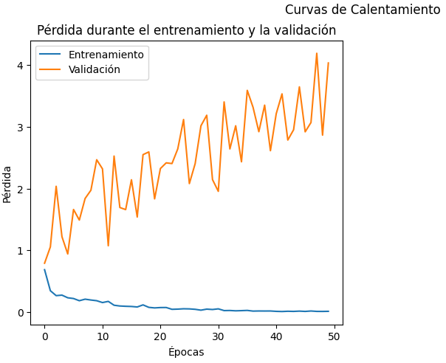

Clase 1 0.50 0.06 0.11 17

accuracy 0.80 84

macro avg 0.65 0.52 0.50 84

weighted avg 0.74 0.80 0.73 84

Test set AUC Score after warmup: 0.6189640035118524

11/11 [==============================] - 5s 500ms/step

Train set classification report after warmup:

precision recall f1-score support

Clase 0 0.87 1.00 0.93 265

Clase 1 0.97 0.43 0.59 70

accuracy 0.88 335

macro avg 0.92 0.71 0.76 335

weighted avg 0.89 0.88 0.86 335

Train set AUC Score after warmup: 0.8155256064690026

Test set classification report after fine-tuning:

precision recall f1-score support

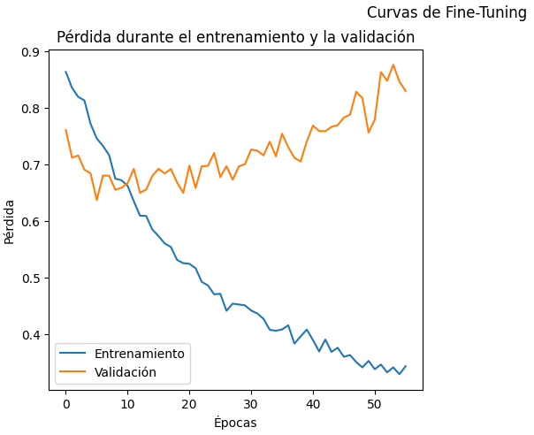

Clase 0 0.90 0.39 0.54 67

Clase 1 0.25 0.82 0.39 17

accuracy 0.48 84

macro avg 0.58 0.61 0.47 84

weighted avg 0.77 0.48 0.51 84

Test set AUC Score after fine-tuning: 0.6426690079016681

11/11 [==============================] - 2s 146ms/step

Train set classification report after fine-tuning:

precision recall f1-score support

Clase 0 0.91 0.51 0.65 265

Clase 1 0.30 0.80 0.44 70

accuracy 0.57 335

macro avg 0.60 0.65 0.54 335

weighted avg 0.78 0.57 0.60 335

Train set AUC Score after fine-tuning: 0.7397304582210242

**Experimento #7**

train_datagen = ImageDataGenerator(

preprocessing_function=preprocess_input,

rotation_range=10,

width_shift_range=0.1,

height_shift_range=0.1,

zoom_range=0.1,

validation_split=0.2

)

Test set classification report after warmup:

precision recall f1-score support

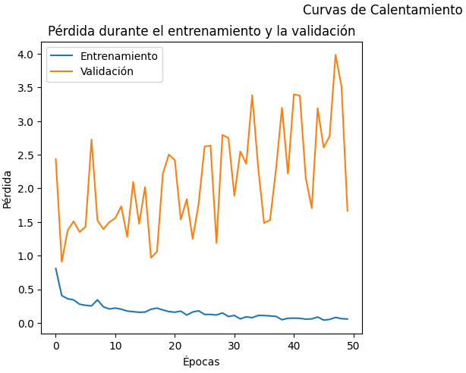

Clase 0 0.81 0.84 0.82 67

Clase 1 0.27 0.24 0.25 17

accuracy 0.71 84

macro avg 0.54 0.54 0.54 84

weighted avg 0.70 0.71 0.71 84

Test set AUC Score after warmup: 0.5750658472344162

11/11 [==============================] - 4s 421ms/step

Train set classification report after warmup:

precision recall f1-score support

Clase 0 0.90 0.98 0.94 265

Clase 1 0.87 0.59 0.70 70

accuracy 0.90 335

macro avg 0.89 0.78 0.82 335

weighted avg 0.89 0.90 0.89 335

Train set AUC Score after warmup: 0.8194609164420485

Test set classification report after fine-tuning:

precision recall f1-score support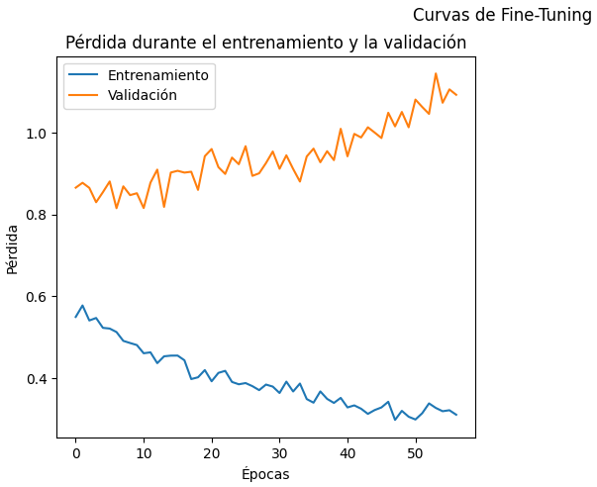

Clase 0 0.84 0.61 0.71 67

Clase 1 0.26 0.53 0.35 17

accuracy 0.60 84

macro avg 0.55 0.57 0.53 84

weighted avg 0.72 0.60 0.63 84

Test set AUC Score after fine-tuning: 0.5812115891132572

11/11 [==============================] - 1s 133ms/step

Train set classification report after fine-tuning:

precision recall f1-score support

Clase 0 0.87 0.69 0.77 265

Clase 1 0.34 0.60 0.44 70

accuracy 0.67 335

macro avg 0.60 0.65 0.60 335

weighted avg 0.76 0.67 0.70 335

Train set AUC Score after fine-tuning: 0.6941239892183289

**Experimento #8**

train_datagen = ImageDataGenerator(

preprocessing_function=preprocess_input,

rotation_range=10,

width_shift_range=0.1,

height_shift_range=0.1,

horizontal_flip=True,

zoom_range=0.1,

brightness_range=[0.8, 1.2],

channel_shift_range=10.0,

validation_split=0.2

)

Test set classification report after warmup:

precision recall f1-score support

Clase 0 0.80 0.90 0.85 67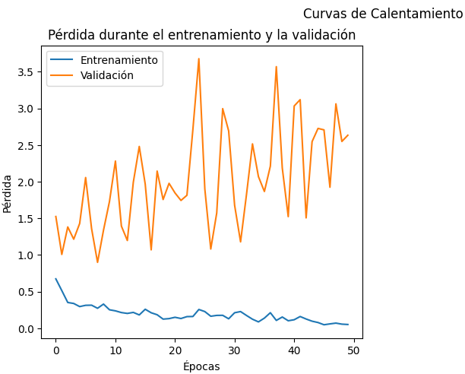

Clase 1 0.22 0.12 0.15 17

accuracy 0.74 84

macro avg 0.51 0.51 0.50 84

weighted avg 0.68 0.74 0.71 84

Test set AUC Score after warmup: 0.6005267778753293

11/11 [==============================] - 5s 464ms/step

Train set classification report after warmup:

precision recall f1-score support

Clase 0 0.89 0.99 0.93 265

Clase 1 0.92 0.51 0.66 70

accuracy 0.89 335

macro avg 0.90 0.75 0.80 335

weighted avg 0.89 0.89 0.88 335

Train set AUC Score after warmup: 0.8197304582210243

Test set classification report after fine-tuning:

precision recall f1-score support

Clase 0 0.84 0.64 0.73 67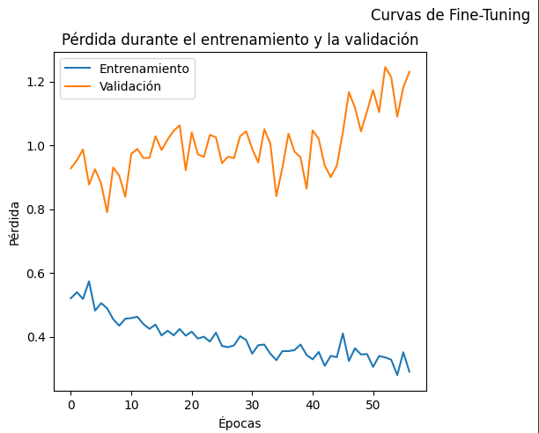

Clase 1 0.27 0.53 0.36 17

accuracy 0.62 84

macro avg 0.56 0.59 0.54 84

weighted avg 0.73 0.62 0.65 84

Test set AUC Score after fine-tuning: 0.5996488147497805

11/11 [==============================] - 2s 147ms/step

Train set classification report after fine-tuning:

precision recall f1-score support

Clase 0 0.91 0.80 0.85 265

Clase 1 0.48 0.69 0.56 70

accuracy 0.78 335

macro avg 0.69 0.74 0.71 335

weighted avg 0.82 0.78 0.79 335

Train set AUC Score after fine-tuning: 0.7795687331536388

**Experimento #9**

train_datagen = ImageDataGenerator(

preprocessing_function=preprocess_input,

horizontal_flip=True,

width_shift_range=0.1,

height_shift_range=0.1,

zoom_range=0.1,

validation_split=0.2

)

Test set classification report after warmup:

precision recall f1-score support

Clase 0 0.80 0.88 0.84 67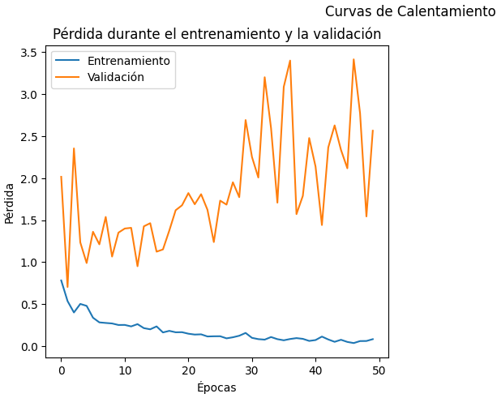

Clase 1 0.20 0.12 0.15 17

accuracy 0.73 84

macro avg 0.50 0.50 0.49 84

weighted avg 0.68 0.73 0.70 84

Test set AUC Score after warmup: 0.6163301141352063

11/11 [==============================] - 5s 438ms/step

Train set classification report after warmup:

precision recall f1-score support

Clase 0 0.88 0.99 0.93 265

Clase 1 0.92 0.50 0.65 70

accuracy 0.89 335

macro avg 0.90 0.74 0.79 335

weighted avg 0.89 0.89 0.87 335

Train set AUC Score after warmup: 0.8223719676549865

Test set classification report after fine-tuning:

precision recall f1-score support

Clase 0 0.92 0.34 0.50 67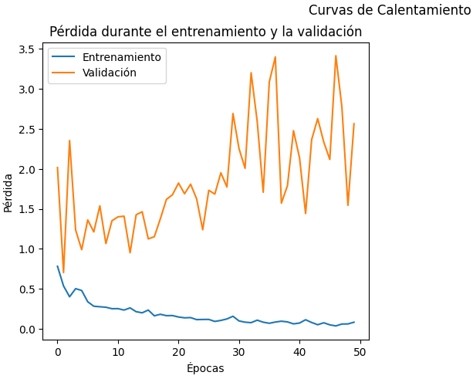

Clase 1 0.25 0.88 0.39 17

accuracy 0.45 84

macro avg 0.59 0.61 0.45 84

weighted avg 0.79 0.45 0.48 84

Test set AUC Score after fine-tuning: 0.6084284460052678

11/11 [==============================] - 2s 139ms/step

Train set classification report after fine-tuning:

precision recall f1-score support

Clase 0 0.91 0.40 0.55 265

Clase 1 0.27 0.84 0.41 70

accuracy 0.49 335

macro avg 0.59 0.62 0.48 335

weighted avg 0.77 0.49 0.52 335

Train set AUC Score after fine-tuning: 0.7029649595687331

### **Parámetros de Data Augmentation**

**Rotation_range**:

Aplica una rotación aleatoria a las imágenes dentro del rango de -10 a 10 grados.

**Width_shift_range**:

Desplaza la imagen horizontalmente en un rango de -10% a 10% del ancho total de la imagen.

**Height_shift_range**:

Desplaza la imagen verticalmente en un rango de -10% a 10% de la altura total de la imagen.

**Horizontal_flip**:

Voltea la imagen horizontalmente con una probabilidad del 50%.

**Zoom_range**:

Aplica un zoom aleatorio a la imagen en un rango de 90% a 110% del tamaño original.

**Brightness_range**:

Ajusta el brillo de la imagen en un rango de 80% a 120% del brillo original.

**Channel_shift_range**:

Ajusta los valores de los canales de color (saturación) de la imagen en un rango de -10 a 10 unidades.

**Validation_split**:

Reserva el 20% de los datos de entrenamiento para la validación.